Report Required SLA Outage Information

Service Level Management

Purpose
This procedure lists instructions for providing necessary information related to SLA outages.

Related Policy
- IT Service Management Policy

Audience
The following groups are responsible for adhering to this document:
- Service Level Management
- JTS support groups
- Systems Innovation Group (SIG)

Procedure
Step | Responsible | Action
1 | Service Level Management | If a Service Level Agreement (SLA) is missed or breached (see glossary for definition), follow the steps below.  - Create an investigation incident ticket.  - Assign the ticket to yourself while researching the outage.  - Review the SLA monitor logs and identify the timeframe of the outage and all error messages.  - Using the outage time frame, search BMC Remedy for incident, change, or problem tickets that may be related to the SLA outage.  - If a change ticket that affects the service falls into the time frame of the SLA outage, relate the change ticket to the investigation ticket using the “caused by” relationship type. Note your findings in the “Resolution” field and resolve the ticket.  - If incident or problem tickets are discovered that fall into the time frame of the SLA outage, add the information to the Work Detail log of the investigation ticket. Request that the information be verified and not, request that information be provided to explain what did cause the SLA outage. Assign the investigation ticket to the appropriate SIG or JTS team.  - If there are no incident or problem tickets discovered that fall into the time frame of the SLA outage, assign the investigation ticket to the appropriate SIG or JTS support team and request that they provide information to explain the cause of the SLA outage.  - If the SIG or JTS team does not identify an outage, re-assign the investigation ticket to the Technical Services team to investigate if the monitoring tool misreported an outage or to identify a true outage.  - If a monitoring tool issue is the cause, create a problem ticket to be researched further to prevent future SLA outages. Assign the problem ticket to Technical Services.
2 |  | If the investigation ticket is not resolved within two business days, send an email to the group, the group’s manager, and SLM Management. In the event that the investigation ticket is not resolved with four business days, notify the SLM Manager to contact the group’s manager.
3 | JTS Support Groups/SIG | Upon receiving an investigation ticket for a missed SLA, provide the following information to Service Level Management so the SLA report can be annotated correctly:  - Reason for the outage.  - Incident, change, or problem number, if applicable.  - If error logs are attached to the investigation ticket, also supply a summary of the error.
4 | Service Level Management | Annotate SLA report.

(See workflow diagram on next page.)

Workflow

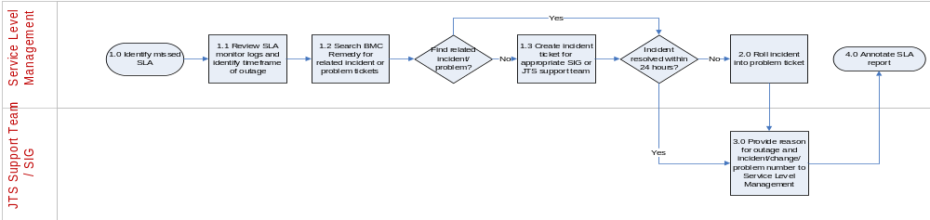

Glossary

Breached SLA – If the actual percentage is less than the compliance Service Target.

Missed SLA – If the actual percentage is less than 100%, but is above the compliance Service Target.

Modification
The following associates can make modifications to this document:
- Manager, Service Level Management
- Director, IT Service Management
- Vice President, Service Delivery, JTS
- Chief Technology Officer, JTS

Report Report Required SLA Outage Information
Responsible Party: Henry Branham, Service Level Management  Approving Authority: Anna Carter, Manager, Service Level Management | Last Modified Date: 19 DEC 2017

